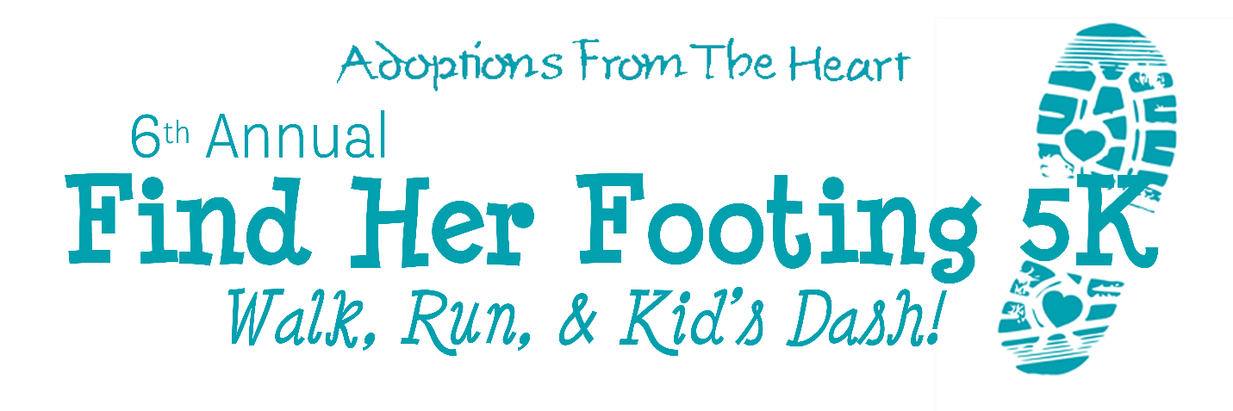 **Sponsorship Request**

To Our Friends at Fortified Roofing,

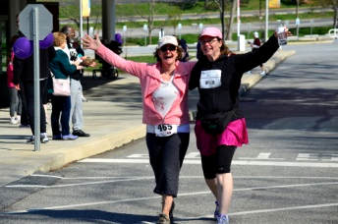

I am writing on behalf of **Adoptions From The Heart**. We warmly invite

Incline Running to participate as a sponsor in our 6th Annual **Find Her Footing 5K*.***

AFTH has been providing children with safe and loving homes since 1985,

while also offering comprehensive, high-quality services to adoptive families,

birthparents and children. We are very proud of our efforts, but we also know that there

is more work to be done. With your help, we would like to pave the way for even better futures

for our families.

Through our 5K, AFTH will raise money for our **Expecting & Birthparent** **Support Fund.** 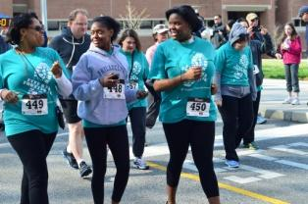

This fund supports mothers who have worked with us, both before & after pregnancy.

Each mother is facing unique challenges and many find themselves in need of

additional financial support to help with housing, food & transportation in order to

regain their footing.

With an estimated 200+ participants and nearly 17,000 Facebook followers we

offer our sponsors an excellent promotional opportunity as well as a philanthropic

community partnership. By sponsoring, you will be able to promote directly to our AFTH

community in Media and the surrounding areas while capitalizing on a profitable marketing opportunity**.**

The benefits of our levels of sponsorship are listed in detail on the next page.

For more information about our **Find Her Footing 5K** visit our “events” page

at afth.org. Please feel free to call or email me to set up a sponsorship or answer any

questions you might have. All donations are tax deductible.   
501:C3 Tax ID: (23‐2372152)

We hope you will consider becoming a sponsor of this wonderful event!

Thank you,

***Reyna Cameron Sara Moyer***

Adoptions From The Heart Adoptions From The Heart

(610)642‐7200 (610)642‐7200

[ReynaC@afth.org](mailto:ReynaC@afth.org) [SaraM@afth.org](mailto:SaraM@afth.org)

Adoptions From The Heart 30‐31 Hampstead Circle, Wynnewood, PA 19096 Attn: Find Her Footing 5K

P: (610)642‐7200 F: (610)642‐7938 www.afth.org

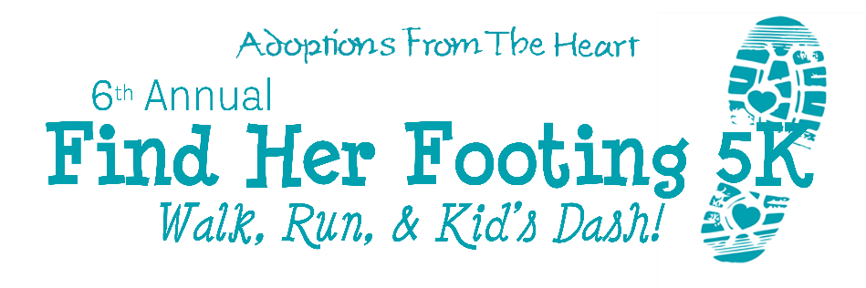

**Sponsorship Registration**



**Organization Name: ___________________________________________________________________  
Address: ____________________________________________________________________________  
City: ______ ______ ______ ______ ______ _____ State: ______ Zip: ____ __   
Phone: ______ ______ ______ ______ Fax: ______ ______ ______ ______   
Contact Person: ______ ______ ______ __________________ ______ _________  
Contact E‐mail: ______ ______ ______ ______ ______ ______ ___________  
Total Amount Enclosed: $______ _______________**

